**TECHNICAL UNIVERSITY – SOFIA**

**PLOVDIV BRANCH**

**FACULTY OF ELECTRONICS AND AUTOMATION**

**FINAL YEAR PROJECT**

**BACHELOR'S DEGREE**

**TITLE:**

**A software system for automatically selecting suitable candidates according to their qualifications**

**STUDENT: Lyubomir Lambrev**

**SUPERVISOR: Vanya Markova , PhD**

**PLOVDIV 2022**

**DECLARATION OF ORIGINALITY OF THE FINAL YEAR PROJECT**

I, the undersigned Lyubomir Lambrev**,** a student in the Industrial Engineering degree course in the Faculty of Electronics and Automation at the Technical University of Sofia, Plovdiv Branch, graduating during the 2021/2022academic year,

faculty No: 510259

declare that the foregoing implementation of the specific tasks related to my final year project, entitled: A software system for Automatically selecting suitable candidates according to their qualifications

with supervisor:

in the volume of ....... text pages and .......... pages with annexes, including number of figures: .........., number of tables: ..........., is the result of my own work.

#### Date::..................... Signature: ..........................................

**A REVIEW OF THE FINAL YEAR PROJECT BY THE SUPERVISOR**

The final year project is performed according to the assignment in full volume **/** in the volume of % (please underline the correctanswer and if the implementation is less than 100 **% ,** a motivation should be filled in and it is mandatory required upon admission to the presentation of a final year project)

and may **/** may not be admitted to presentation.

#### Motivation:......................................................................................................................... ….......................................................................................................................................

Signature: **................................**

#### (Supervisor)

#### Selected reviewer:............................................................................................................

Signature: ................................

(Head of Department)

Table of Contents

1. Introduction

2. State of the Art and trends

2. 1. Global Labor Shortage

2. 2. How can automation help alleviate labor shortage

2. 3. Benefits of an automated recruitment system

3. Formulation of design Structure

3.1 Fitting Function

3.2 Utility Function

4. Basic Theory

5. Experiments and analysis

6. Conclusions

Introduction

Chapter 1

In this work, an application is developed to allocate the most suitable applicants to certain positions. The selection is made on the basis of the highest score presented qualifications and skills of the applicant.

A program is written to find the best arrangement for each applicant and the corresponding workplace.

The list of jobs is provided by the employer, and the list of applicants by the employment agency. We will consider evaluating each applicant's qualification (competence) as the number of years of experience of the applicant.

**What is a conceptual model?**

A conceptual model is the model of an application that the designers want users to understand. By using the software and perhaps reading its documentation, users build a model in their minds of how it works.

**What is MVC**

Model–view–controller (MVC) is a software architectural pattern commonly used for developing user interfaces that divide the related program logic into three interconnected elements. This is done to separate internal representations of information from the ways information is presented to and accepted from the user

**Components of MVC:**

*Model* – The central component of the pattern. It is the application's dynamic data structure, independent of the user interface. It directly manages the data, logic and rules of the application.

*View* - Any representation of information such as a chart, diagram or table. Multiple views of the same information are possible, such as a bar chart for management and a tabular view for accountants.

*Controller* - The Controller is that part of the application that handles the user interaction. It interprets the inputs from the user, informing the model and the view to change as appropriate. input and converts it to commands for the model or view

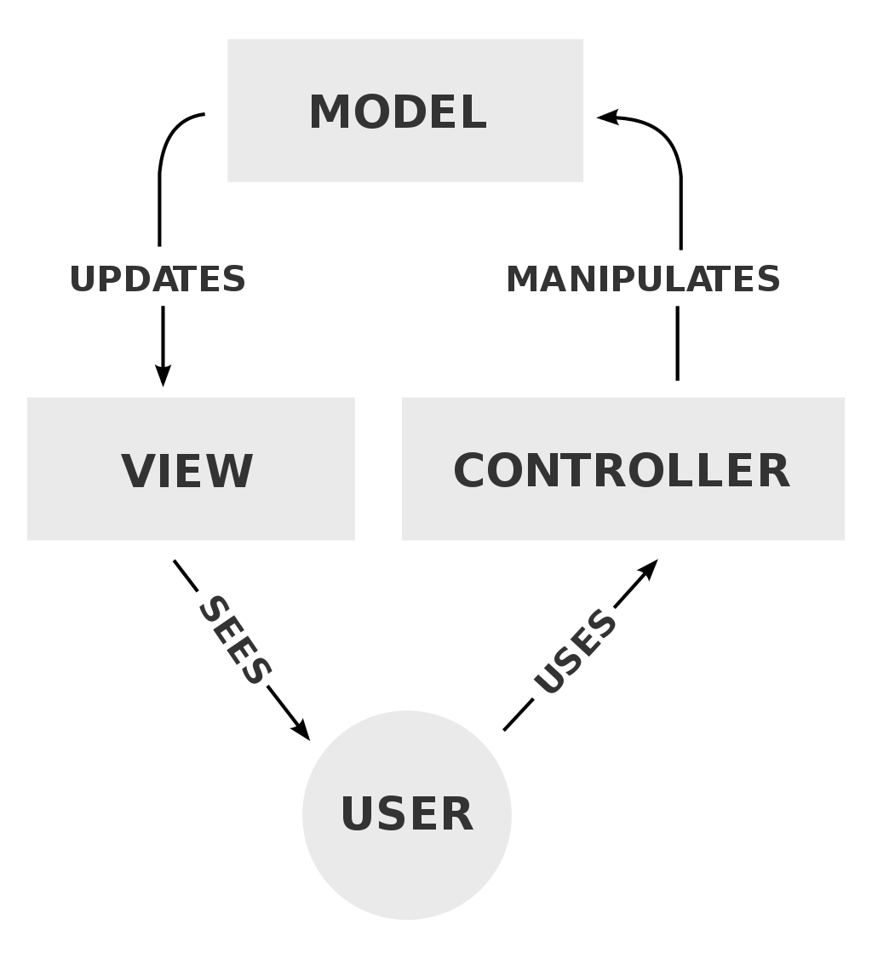

**1. Global Labor Shortage**

Typically, a labor shortage occurs when there are not enough available workers participating in the labor market to meet the demand for employees. For example, in the United States, there are nearly 11 million job vacancies, but only 6.5 million workers are listed as unemployed in 2022. This high level of job openings is not only affecting employers in the United States. For example, as of early 2022, employers in Europe were struggling to fill over 1.2 million open job roles[].

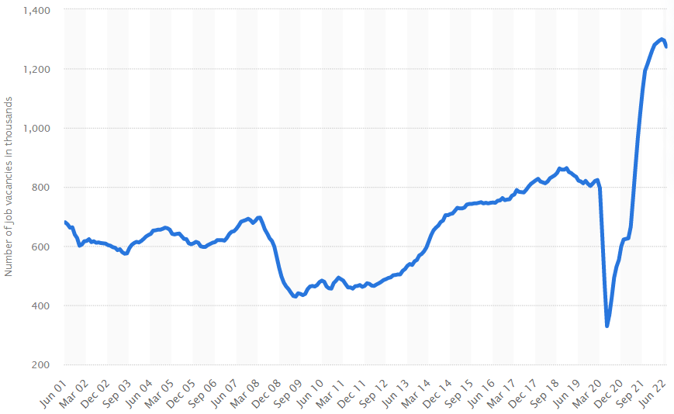Fig.6. Number of job vacancies in the United Kingdom from 2001 to 2022[]

What are the driving forces behind the labor shortage? While the impact of the current labor shortage varies by location and sector, it’s undoubtedly one of the biggest challenges in modern history. An ongoing labor shortage could significantly impede the world’s ability to fully recover in a post-pandemic market.

1. Covid-19

It would be impossible to discuss the current labor without acknowledging the global pandemic’s role on it. As of March 2022, WHO has reported more than 6 million people deceased due to the pandemical-related issues, while millions of others are dealing with the long-term effect of the virus. This factor alone has caused major disruptions to workplaces around the world. The lingering global pandemic has spurred a number of challenges for employers and employees, including:

* Mental health issues

Early into the pandemic, mental health professionals started to express concerns regarding the global pandemic’s impact on workers’ mental health. Today it looks like these warning are proving true

* Immigration disruptions

Migrant workers make up 5% of the global workforce. Countries such as the United States, Saudi Arabia, United Arab Emirates, Canada, Germany and the United Kingdom depends heavily on these workers to meet production demands. The pandemic significantly hindered this dependency as countries set stricter immigration policies to control the spread of the virus within their borders.

* Shift in workers expectations

Throughout the pandemic, many employees faced additional pressure at work, such as sudden layoffs and lockdowns and extraordinary personal challenges, including homeschooling their children and caring for ageing parents. These stressors have spurred a shift in workers’ expectations. At the forefront of these expectations is the desire to maintain a healthy work-life balance.

Furthermore, some workers are willing to change jobs to get the flexibility they need or leave the workforce altogether if they can’t find it. In fact, a recent study by Monster Shows that 95% of workers are open to changing jobs, and 92% are willing to change industries if necessary.

2. Low wages

While some workers are leaving the workforce altogether, the majority are simply changing jobs due to better job opportunities. Some are leaving for higher salaries. The ongoing labor shortage has created a candidate-driven market in most areas of the world. Many employees and jobseekers are requesting higher wages and improved benefits. However, these wage increases vary across the globe.

In some areas of the world, worker’s pay increases may not be enough to cover the cost of rising inflation. For example, in the United States, hourly wages rose by 4.7% in December 2021, but inflation rose by 7% during the same period. For workers in these areas, increased salaries are even more important.

3. Ageing Population

Another factor impacting today’s labor shortage is the world’s ageing population. For years, employers in many countries have had concerns about replacing record numbers of retiring workers. The combination of an ageing population and a falling birth rate means that there will be fewer people available to work.

**Which industries are most impacted by the labor shortage?**

While nearly every industry is affected in some way by the growing labor shortage, there are a few sectors where the impact is larger:

1. Healthcare

The healthcare industry was hit hard during the pandemic. Not only did these essential workers risk their lives, as well as those of their families, by going to work every day, but many also had to work long hours due to staffing shortages.

For example, 57% of nurses in the U.K. are considering leaving their jobs, while 32% of U.S. registered nurses want to leave their direct-patient roles.

Globally, the International Council of Nurses warns that as much as half of the current nursing workforce could leave the profession within the next few years. This issue could lead to a global crisis in under a decade.

1. Manufacturing

For the past years, the global manufacturing industry’s main concern has been labor shortages. These shortages are due in large part to a lack of workers with technical skills. Other factors include increasing retirement rates, growing complexity in the global supply chain, and academia. The global manufacturing labor shortage could exceed 8 million people by 2030, resulting in a possible revenue loss of $607 billion. Countries that already struggle with shortages are expected to get worse.

According to a report done by The Manufacturing Institute and Deloitte, the U.S. manufacturing sector will need to fill 4.6 million jobs in the next decade, but nearly 2.5 million jobs may not be filled due to a lack of skilled workers.

1. Supply chain

Logistics is another sector that is struggling to attract workers before and after the pandemic. This labor shortage is not isolated to just one region of the world.

For instance, employers in the U.S. are struggling to fill 80,000 open trucking vacancies, while the U.K. is seeing a shortage of over 100,000 truck drivers. This ongoing labor shortage is expected to bring an 18% shortage of truck drivers in Mexico and a 24% shortage of drivers in Turkey.

**What impact does the labor shortage have?**

The ongoing labor shortage can not only hinder company growth; it may also impact society as a whole. For example, supply chain disruptions have already resulted in product shortages.

Another problem that many experts are closely watching is rising inflation. While there’s still some debate whether the labor shortage contributes to inflation, many believe that today’s labor shortage will result in increased wages, higher prices and slower post-pandemic recovery. If left unchecked, inflation could bring about a serious crisis that could take years, or decades, to resolve.

**How Can Automation Help Alleviate Labor Shortages?**

Labor shortages are often discussed in fields such as logistics, but a growing number of industries have more job openings than people to fill them. Manufacturing, education, health services and retail are many industries struggling to bring in new hires and retain existing employees.

Automation and robotics may have a negative reputation for stealing people’s jobs, but in almost every case, it supplements floundering workforces. Here’s how it can help alleviate labor shortages in various industries and help bolster the economy.

**Labor Shortage Statistics**

Looking at any industry from the outside, it might seem like everything is working as it’s meant to. However, behind the scenes, the problem becomes glaringly apparent. Foodservice and hospitality-related businesses experienced a 6.6% quit rate in September 2021.

Durable goods manufacturing is seeing even worse resignation levels. Companies are struggling to hire enough workers to fill vacant positions and stay ahead of the competition.

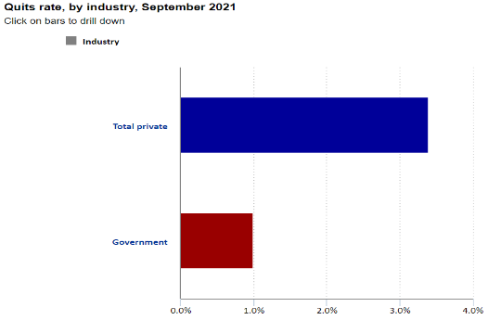

Fig.7. Quit rates, by industry, September 2021

Industries worldwide have lost millions of workers due to COVID-19 and the Great Resignation that followed. Many of those who left the workforce during the pandemic decided that taking early retirement was a better option than returning to work once things returned to normal. The best choice for employers would be to make the necessary changes to bring in new workers and retain those already employed. However, automation may be able to help fill in some of the gaps.

**Freeing up Skilled Workers for Critical Tasks**

Most industries have many mundane or repetitive tasks that are necessary to complete the job. They are all necessary, but thanks to automation, they do not need to take up the time or skills of an employee better suited to more complex or critical work. Relegating these mundane or repetitive tasks to robotics or automation services can also help reduce the number of repetitive stress injuries in the workplace.

Poor posture, repeated motions and other repetitive movements can cause injuries which, in turn, can lead to missed work and workers’ compensation claims. Widespread use of automation and material handling solutions could help reduce those numbers dramatically.

***2. Benefits of an automated recruitment system***

As you can probably picture, automating your most repetitive and time-consuming tasks brings benefits for your overall recruitment system. Here are just some of the primary benefits from implementing an automated recruitment system.

**2.1Avoiding bottlenecks in the recruitment pipeline**

By automating your most common tasks, you can ensure that you never have a backlog of work sitting on a team members’ desk, holding up the entire hiring process. This is especially important if you work as a recruiter for a high-turnover industry such as call centers. One of the primary factors that contribute to inefficient recruitment funnels, and lost opportunities to hire top talent, is lengthy delays in moving applicants through the pipeline.

Automation can help prevent these situations by ensuring that all of the most important, but simple, tasks aren’t piling up somewhere. Instead, candidates are able to move smoothly through the pipeline, and recruiters are able to easily meet deadlines and make decisions on who to hire.

Some of the ways that an automated recruitment system can help you avoid bottlenecks include:

* Filtering applicants quickly
* Avoiding overloading
* Notifying team immediately when actions need to be taken
* Automatically flagging at-risk deadlines

Together, these automated actions can help to ensure that your recruitment funnel is always running smoothly. Which brings us to the second benefit.

**Eliminate time and waste**

Eliminating bottlenecks and improving the overall efficiency of your pipeline helps to eliminate time and resource waste that can lead to the overall poor performance of your recruitment process. Delays and missed steps due to task overload can cause lost productivity and revenue by failing to fill a skills gap when it’s needed.

Additionally, sourcing and screening candidates takes both monetary and human resources, both of which can be very expensive for the organization. Wasting that money and effort due to a lack of automation, or because of task overload, is simply not a good business move for your company.

Some examples of how automation can help to eliminate time and waste include:

* Eliminating the need to manually call non-responsive or unqualified candidates
* Freeing recruiters from repeating the same task over and over again
* Automatically identifying areas of inefficiency and waste

By automating the most time-consuming tasks, and continuously monitoring the efficiency of your recruitment process, you can drastically reduce the amount of costly waste at your company.

**Focus your time on top talent**

A recruiter’s job should mostly focus on finding and engaging with high potential applicants who will make a real difference at the organization.

Implementing an automated recruitment system will allow your recruiters to focus on doing just that, rather than tasks that don’t really move the dial for your organization.

**Reactivate candidates to fill your talent pipeline**

Automated recruitment systems are able to regularly, at scheduled times, scrape your existing database for qualified candidates who fit the bill for a current or future job opening. Once reactivated, these passive candidates can then be engaged either by automated communications, or directly from a recruiter.

**Improve applicant experience**

An automated recruitment system that eliminates bottlenecks, delays, and missed communications contributes to an overall better candidate experience for your applicants. If there’s one thing that can ruin an applicants’ opinion of your organization it’s poor communication, and not following through on what you say you’re going to do.

By ensuring that all of the crucial touch points are covered, automated actions can ensure that every applicant, no matter what the outcome, receives a solid candidate experience. And of course, maintaining a great candidate experience also contributes to a great employer brand, which is critical to attracting top talent to your team.

**Improve quality of hire**

Naturally, each of the benefits above will ultimately contribute to better hiring results overall. An automated and systematic approach to hiring that’s driven by analytics and continuous improvement means that you and your recruitment team can continuously hone your recruitment process.

As you continue to audit and improve your process, the overall efficiency and quality of your decision making will also continue to elevate to the next level. The end result is, ultimately, hiring better people, more frequently, with less effort than you had to put in before.

**Increase workforce diversity**

Automated recruitment systems help to eliminate much of this inherent human bias. Rather than relying on a subjective reading of a resume to determine if a candidate moves on to the next round, for example, automation can make that decision for you without any inherent bias. This can be extrapolated out too many different critical touch points in the recruitment funnel that may be affected by bias.

Recruitment automation systems carry with them a wide range of benefits and use cases that should be of interest to most recruitment teams. If you’re considering adopting automation into your recruitment process, the best place to start is by looking at where your team is spending most of their time, and which tasks they’re least excited to do. More often than not, these will be tasks that a machine could happily take off their hands.

**3. Hungarian Algorithm**

Harold W. Kuhn, in his celebrated paper entitled The Hungarian Method for the assignment problem, described an algorithm for constructing a maximum weight perfect matching in a bipartite graph. In his delightful reminiscences, Kuhn explained how the works (from 1931) of two Hungarian mathematicians, D. Konig and E. Egervary, had contributed to the invention of his algorithm.The Hungarian method is a combinatorial optimization algorithm that solves the assignment problem in polynomial time and which anticipated later primal–dual methods. It was developed and published in 1955 by Harold Kuhn.

* Combinatorial optimization is a subfield of mathematical optimization that consists of finding an optimal object from a finite set of objects, where the set of feasible solutions is discrete or can be reduced to a discrete set. Typical combinatorial optimization problems are the travelling salesman problem, the minimum spanning tree problem, etc.

In many such problems, such as the ones previously mentioned, exhaustive search (Brute Force) is not tractable, and so specialized algorithms that quickly rule out large parts of the search space or approximation algorithms must be resorted to instead.

In order not to describe a lot of theory with mathematical terms and definitions, we consider a couple of options for constructing an assignment problem, which we will immediately understand in which cases the Hungarian method is applicable:

* The task of assigning employees to positions. It is necessary to distribute employees to positions so that maximum efficiency is achieved, or there are minimum costs for work.
* Assignment of machines to production sections. The distribution of machines so that when they work, production is as profitable as possible, or the cost of their maintenance is minimal.
* Selection of candidates for various vacancies according to their estimates.

there are many options for which the Hungarian method is applicable, while similar tasks arise in many areas of activity. As a result, the problem must be solved in such a way that one executor (man, machine, tool, etc.) can perform only one job, and each job is performed by only one executor. A necessary and sufficient condition for solving a problem is its closed type. When the number of performers = the number of works (N=N). If this condition is not met, then you can add fictitious performers, or fictitious works, for which the values in the matrix will be zero. This will not affect the solution of the problem in any way, it will only give it the necessary closed type.

*Example of a problem*: Let an important scientific conference be planned. To conduct it, you need to set up sound, light, images, register guests and prepare for breaks between performances. There are 5 organizers for this task. Each of them has certain ratings for the performance of a particular job (suppose that these ratings are set as the arithmetic average of the reviews of their employees). It is necessary to distribute the organizers so that their total score is maximum.

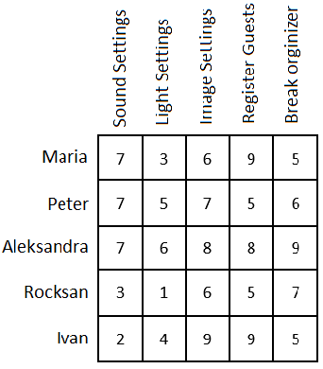  
In each row of the matrix, it is necessary to find the maximum element, subtract it from each element of the corresponding row and multiply the entire matrix by -1.

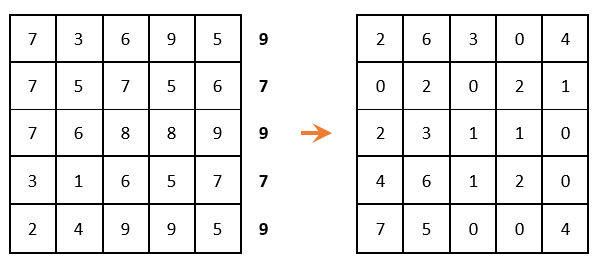  
There must be only one selected zero per row and per column. (i.e., when zero is chosen, then the remaining zeros in this row or in this column are no longer taken into account).

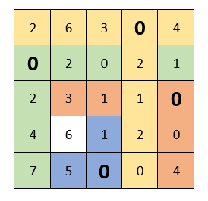  
The next step is Matrix reduction by rows (we look for the minimum element in each row and subtract it from each element, respectively):

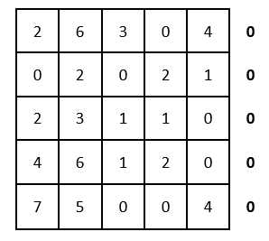  
 Because all minimal elements are zero, then the matrix has not changed. We carry out the reduction by columns:

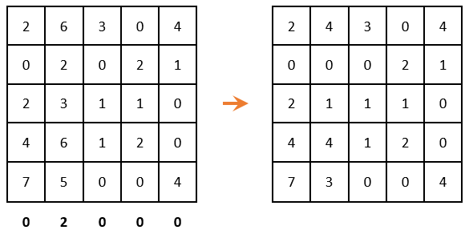  
Again, we look to ensure that in each column and in each row, there is only one selected zero. There are two options for choosing zeros, but none of them gave the desired result

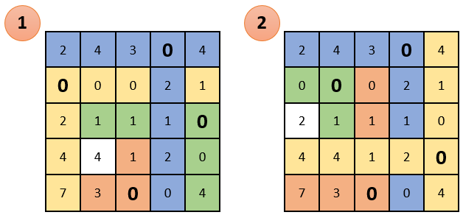  
cross out rows and columns that contain zero elements (IMPORTANT! The number of cross outs should be minimal). Among the remaining elements, look for the minimum, subtract it from the remaining elements (which are not crossed out) and add to the elements that are located at the intersection of the crossed-out rows and columns (what is marked in green - subtract there; what is marked in gold - summarize there; then, what is not painted over - do not touch):

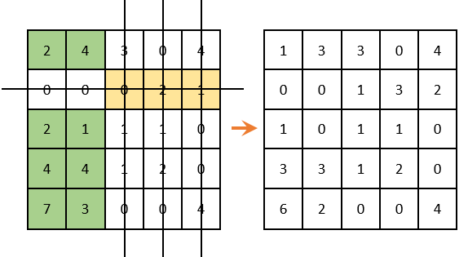  
there is only one selected zero in each column and row. The solution is complete

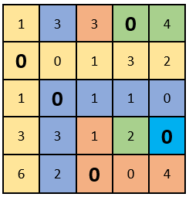  
If there is a problem in the solving and it is still impossible for you to choose zeros so that there is only one in each column and row, then we repeat the algorithm from the place where the row reduction was carried out (the minimum element in each row).

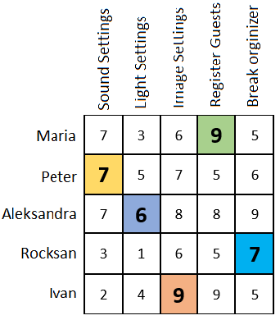  
substitute the locations of the selected zeros in the initial table. Thus, we get the optimum, or the optimal plan, in which the organizers are distributed among the works and the sum of the marks is maximum:

**4. Brute-Force Algorithm**

brute-force search or exhaustive search, also known as generate and test, is a very general problem-solving technique and algorithmic paradigm that consists of systematically enumerating all possible candidates for the solution and checking whether each candidate satisfies the problem's statement.

A brute-force algorithm that finds the divisors of a natural number n would enumerate all integers from 1 to n, and check whether each of them divides n without remainder. A brute-force approach would examine all possible arrangements.

While a brute-force search is simple to implement and will always find a solution if it exists, implementation costs are proportional to the number of candidate solutions – which in many practical problems tends to grow very quickly as the size of the problem increases. Therefore, brute-force search is typically used when the problem size is limited, or when there is a problem-specific that can be used to set of candidate solutions to a manageable size. The method is also used when the simplicity of implementation is more important than speed.

Indeed, brute-force search can be viewed as the simplistic. It should not be confused with backtracking, where large sets of solutions can be discarded without being explicitly enumerated. The brute-force method for finding an item in a table – namely, check all entries of the latter, sequentially – is called linear search.

**Pros and cons of Brute-Force Algorithm**

**Pros:**

* The Brute-Force approach is a guaranteed way to find the correct solution by listing all the possible candidate solutions for the problem.
* It is a generic method and not a limited to any specific domain of problems.
* The brute force method is ideal for solving small and simpler problems.
* It is known for its simplicity and can serve as a comparison benchmark.

**Cons:**

* The Brute-Force is inefficient. For real-time problems.
* This method relies more on compromising the power of a computer system for solving a problem than a good algorithm design.
* Brute-Force algorithms are slow.
* Brute-Force algorithms are not constructive or creative compared to algorithms that are constructed using some other design paradigms.

**1.8 Software tools**

**Streamlit** is a free and open-source framework to rapidly build and share beautiful machine learning and data science web apps. Users instantly develop web apps and deploy them easily using it. It’s also a Python-based library specifically designed for machine learning engineers and Data scientists. Streamlit is easier to learn and to use rather than other more complicated frameworks which will take much more time to learn, it is simple as long as it can display data and collect needed parameters for modeling[].

Working with Streamlit is straightforward. First the code is written using Streamlit commands into a normal Python script, then it is run with the command “Streamlit run (name of the file)” in the Prompt. As soon as the script is running, a local Streamlit server will show up and the app will open in a new tab in the default web browser. The app is the users canvas, where users draw charts, text, widgets, tables, and more.

*Development flow*. Every time the user wants to update the app, source file needs to be saved and it will automatically update. When the user does that, Streamlit detects if there is a change and asks whether the user want to rerun the app. if Chosen "Always rerun" (at the top-right of the screen) it will automatically update the app every time there is a change in the source code. This allows users to work in a fast interactive loop: users type some code, save it, try it out live, then type some more code, save it, try it out, and so on until users are happy with the results. This tight loop between coding and viewing results live is one of the ways Streamlit makes your life easier.

*Data flow*. Streamlit's architecture allows you to write apps the same way you write plain Python scripts. Streamlit apps have a unique data flow. Whenever a callback is passed to a widget or parameter, the callback will always run before the rest of the script. And to make all of this fast and seamless, Streamlit does some heavy lifting for you behind the scenes. A big role plays the cache detector, which allows developers to skip certain costly computations when their apps rerun. [streamlit.io]

**Python and Anaconda**

*Python-* Python is an interpreted, object-oriented, high-level programming language with dynamic semantics. Its high-level built in data structures, combined with dynamic typing and dynamic binding, make it very attractive for Rapid Application Development, as well as for use as a scripting or glue language to connect existing components together. Python's simple, easy to learn syntax emphasizes readability and therefore reduces the cost of program maintenance. [python.org]

*Anaconda-* Anaconda is a distribution of the Python and R programming languages for scientific computing (data science, machine learning applications, large-scale data processing, predictive analytics, etc.), that aims to simplify package management and deployment. The distribution includes data-science packages suitable for Windows, Linux, and macOS. Package versions in Anaconda are managed by the package management system conda. [anaconda.com]

**Argparse-** The argparse module makes it easy to write user-friendly command-line interfaces. It parses the defined arguments from the sys.argv.

The argparse module also automatically generates help and usage messages, and issues errors when users give the program invalid arguments. It is also a standard module.There is no need for installation.

A parser is created with ArgumentParser and a new parameter is added with add_argument. Arguments can be optional, required, or positional. [python.org]

**Spyder-** Spyder is a free and open source scientific environment written in Python, for Python, and designed by and for scientists, engineers and data analysts. It features a unique combination of the advanced editing, analysis, debugging, and profiling functionality of a comprehensive development tool with the data exploration, interactive execution, deep inspection, and beautiful visualization capabilities of a scientific package.It has the following components: Editor, IPython Console, Variable Explorer, Plots, Debugger, Helper. [spyder-ide.org]

**Pandas-** Pandas is a fast, powerful, flexible and easy to use open source data analysis and manipulation tool, built on top of the Python programming language**.** It is most widely used for data science/data analysis and machine learning tasks. Pandas is built on top of another package named Numpy, which provides support for multi-dimensional arrays. As one of the most popular data wrangling packages, Pandas works well with many other data science modules inside the Python ecosystem, and is typically included in every Python distribution. [pandas.pydata.org]

**Numpy-** NumPy is the fundamental package for scientific computing in Python. It is a Python library that provides a multidimensional array object, various derived objects (such as masked arrays and matrices), and an assortment of routines for fast operations on arrays, including mathematical, logical, shape manipulation, sorting, selecting, I/O, discrete Fourier transforms, basic linear algebra, basic statistical operations, random simulation and much more.At the core of the NumPy package, is the ndarray object. This encapsulates n-dimensional arrays of homogeneous data types, with many operations being performed in compiled code for performance. [numpy.org]

**CSV-** CSV stands for comma-separated values, which is a delimited text file that uses a comma to separate values. Each line of the file is a data record. Each record consists of one or more fields, separated by commas. The use of the comma as a field separator is the source of the name for this file format. A CSV file typically stores tabular data (numbers and text) in plain text, in which case each line will have the same number of fields.

The CSV file format is not fully standardized. Separating fields with commas is the foundation, but commas in the data or embedded line breaks have to be handled specially

Chapter 2

We make a MVC that means that the code will be split into 4 parts

As previously said a program must be written to find the best arrangement for each applicant and the corresponding workplace.

**The design structures of the program are as follows:**

The list of jobs is provided by the employer, and the list of applicants by the employment agency

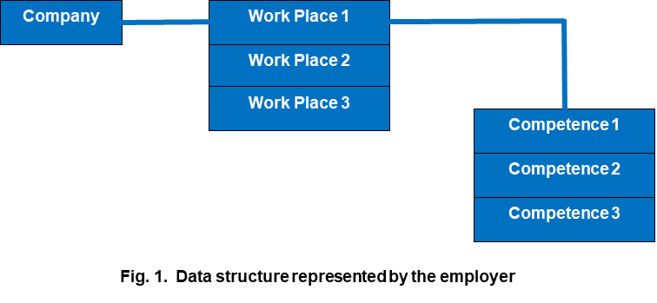

Fig.1. Data structure represented by employer

We will consider evaluating each applicant's qualification (competence) as the number of years of experience of the applicant.

Functions of the program:

Fitting function – Determines to what extent a give competence is covered by the applicant. The fitting function brings back a numerical value (metric, grade). For that reason, there are 3 outcomes:

1. When the competence is required by the employer and possessed by the applicant (we return the number of years of the applicant).

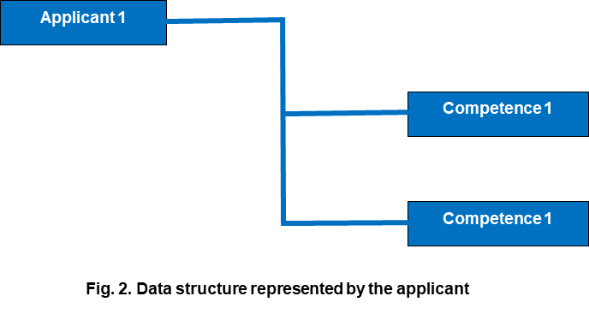

Fig.2. Data structure represented by employer

1. When the competence is required by the employer, but the applicant does not have such a qualification, we return 0.
2. When the applicant has a qualification that is not required at the work place, we return 0.

It is important to return 0 and not Nan or None so that we can sum later in the other functions.

**Utility function** - This function returns the sum of all fitting values of the ordered pair (Applicant, Workplace) --> utility_value.

The ordinance is a way of describing the relationship between the workplace and the applicants.

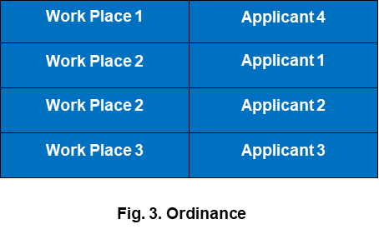

Fig.3. Data structure represented by employer

Algorithm of full enumeration:

1. We load the list of Workplaces.
2. We load the list of Applicants.
3. We create a list of all possible ordinances.
4. We calculate the utility_value for each item in this list.
5. We find the max utility_value from this list.

This is the so-called naive approach or the method of full enumeration.

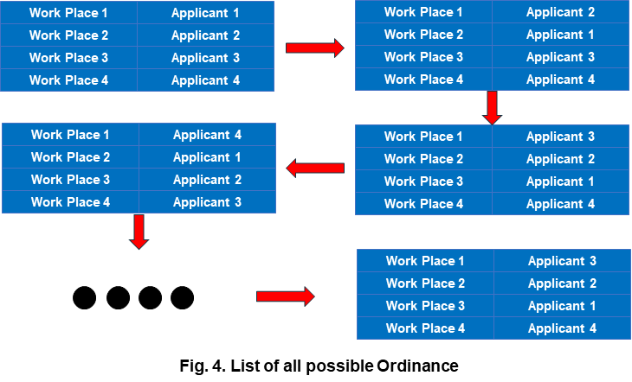

Fig.4. *List of all possible Ordinance*

there are many options for which the Hungarian method is applicable, while similar tasks arise in many areas of activity. As a result, the problem must be solved in such a way that one executor (man, machine, tool, etc.) can perform only one job, and each job is performed by only one executor. A necessary and sufficient condition for solving a problem is its closed type. When the number

**Conceptual model.** A conceptual model of a system is an abstract description of what that system is supposed to do.

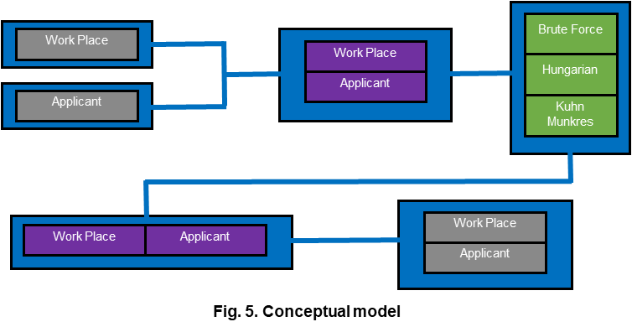

Fig.5. Conceptual model

converting data structures and preparing them to find an optimal linear sum.

Аs input we have two python dictionaries(Java hasmap, C++ map, Javascript associative array)

|  |  |  |  |
| --- | --- | --- | --- |
|  | Communication | Problem solving | Learning |
| Josh | 8 | 7 | 5 |
| Maria | 3 | 0 | 2 |
| Michael | 4 | 5 | 4 |

|  |  |  |  |
| --- | --- | --- | --- |
|  | Communication | Problem solving | Learning |
| Manager | 6 | 6 | 5 |
| Lead Developer | 4 | 4 | 4 |
| Secretary | 2 | 0 | 2 |

Тhese two dictionaries need to be converted into a two-dimensional array more precisely np.array for this purpose we first make a transient array.

|  |  |  |  |
| --- | --- | --- | --- |
|  | Manager | Lead Developer | Secretary |
| Josh |  |  |  |
| Maria |  |  |  |
| Michael |  |  |  |

in the cells of this array we put corresponding values from the fitting function, passing input corresponding to applicant-job(tuple). We then record the results in a dictionary called fit_val. We fill this dictionary by traversing the elements of my_new_df_app first and then the elements of my_new_df_jobs in a double loop, after that we create a new np.array = m in which we again traverse in a double loop with the data from the dictionary fit_val. In the next step we pass the np.array m to scipy.optimize linear_sum_assignment, as a result we get a tuple consisting of the maximum sum of the utility function in regards to the assignment conditions. The second part of the returned result is a one-dimensional array with the indices of the corresponding jobs.

this array has the form :[0,2,1]

In an implicit form, the indexes of applicants are also present, so the assignment results can be presented as follows:[(0,0),(1,2),(2,1)]

The relationship between the explicit and implicit indices in the m matrix and the keys in the fit_val dictionary can be represented as such:

using unique_app and unique_job we convert numeric indices to strings

[(0,0),(1,2),(2,1)]–>[(“Josh”,”Manager”),(“Maria”,”Secretary”),(“Michael”,Lead Developer)]

Chapter 3

**Example assignment**

A competition has been announced by company 1 (C-1) with three jobs. Each job has a set of 2 to 5 competences

For example:

Competence 1,2,5 is required for job 1. Three applicants appear, each of them having from 1 to 5 competence (these candidates have passed preliminary selection so that each of them has the permissible competence). We make the necessary permutations.

For each element of the permutation, we calculate the total sum of competence. The item with the max amount is the one we are looking for.

References

1.<https://www.bls.gov/news.release/pdf/empsit.pdf>

2.<https://www.bls.gov/news.release/jolts.nr0.htm>

3. [https://www.statista.com/statistics/283771/monthly-job-vacancies-in-the-united-kingdom-uk/#:~:text=The%20number%20of%20job%20vacancies,when%20compared%20with%20January%202021](https://www.statista.com/statistics/283771/monthly-job-vacancies-in-the-united-kingdom-uk/" \l ":~:text=The number of job vacancies,when compared with January 2021).

4.<https://hrexecutive.com/astounding-number-of-workers-looking-for-new-jobs-whats-hrs-move/>

5.<https://globaledge.msu.edu/blog/post/56844/global-manufacturing-labor-shortages>

6.https://www.bls.gov/opub/ted/2021/quits-rate-6-6-percent-in-accommodation-and-food-services-in-september-2021.htm

7.

8.